WEEK 2

DSE & DBD WEEK 2 PRACTICAL
Name: M.Akhila
Roll No: 2520030511
Course Code: 25CS1302E
JOINS, AGGREGATIONS, TRANSACTIONS AND INDEXING

Aim:
To practice SQL JOIN operations, aggregate functions, transaction management, foreign keys and indexing using MySQL Workbench.
Software Used:
MySQL Workbench
Database Name:
bookflow_db

SQL Operations Performed
- Create Database
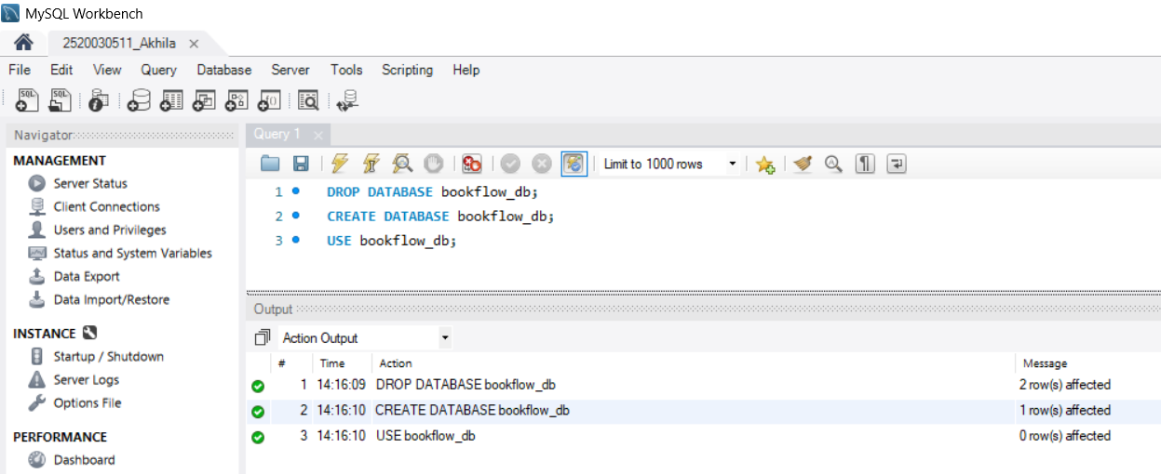
- Create Books Table (DDL + Constraints)
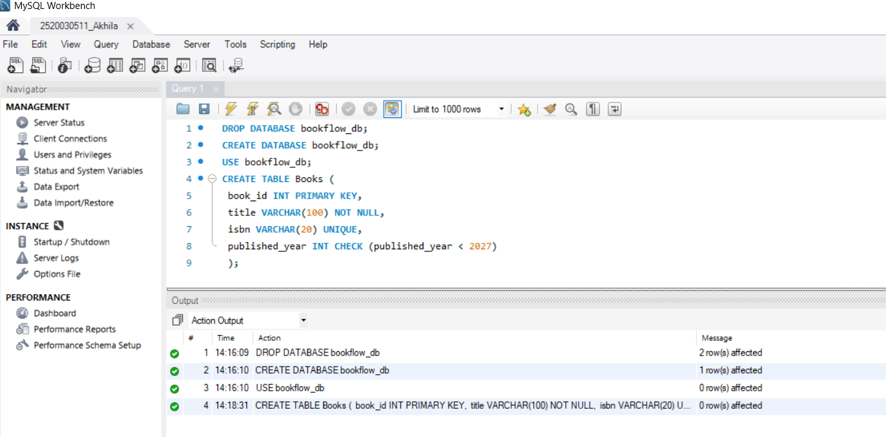

- Insert Books and Display

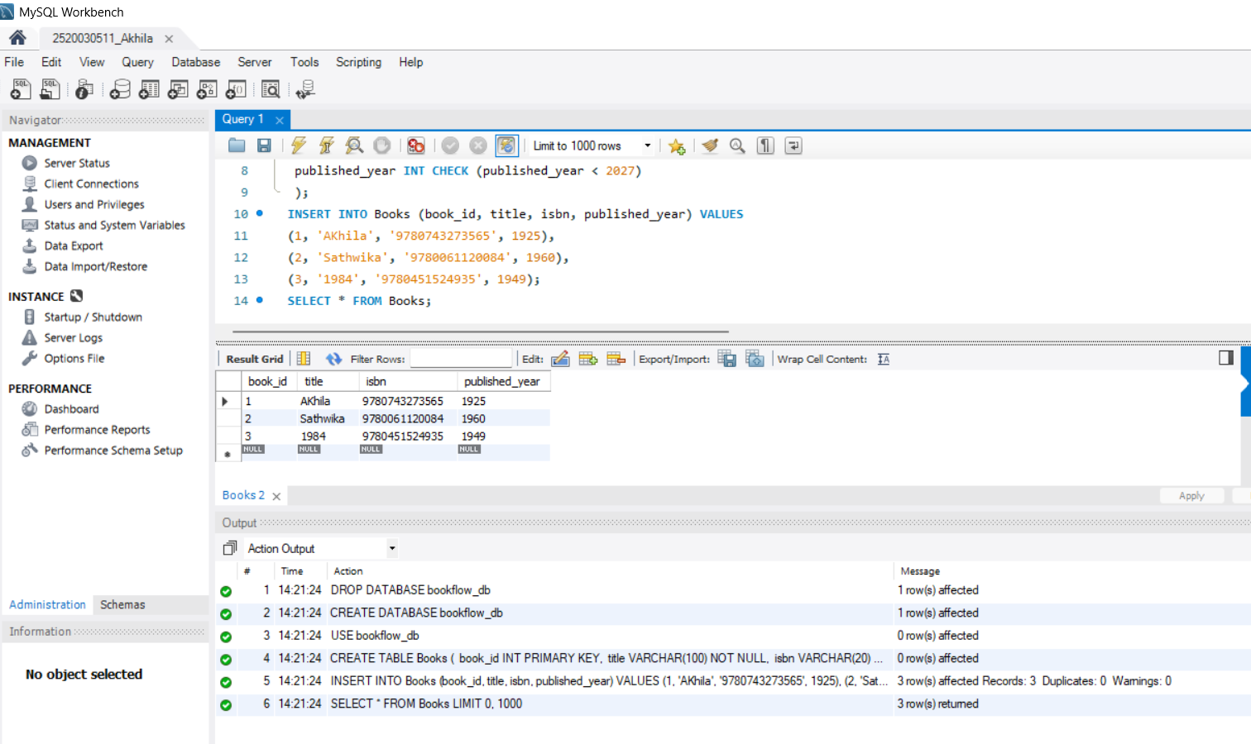

- Members Table: Create, Insert, Display

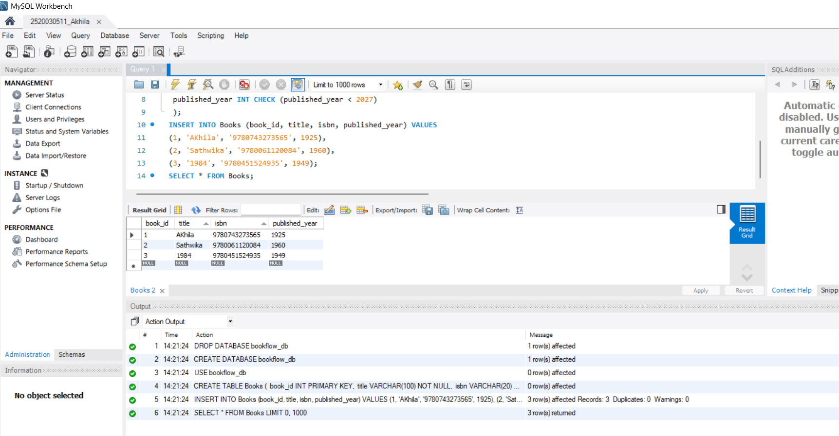

- Create Loans Table (FOREIGN KEYS)

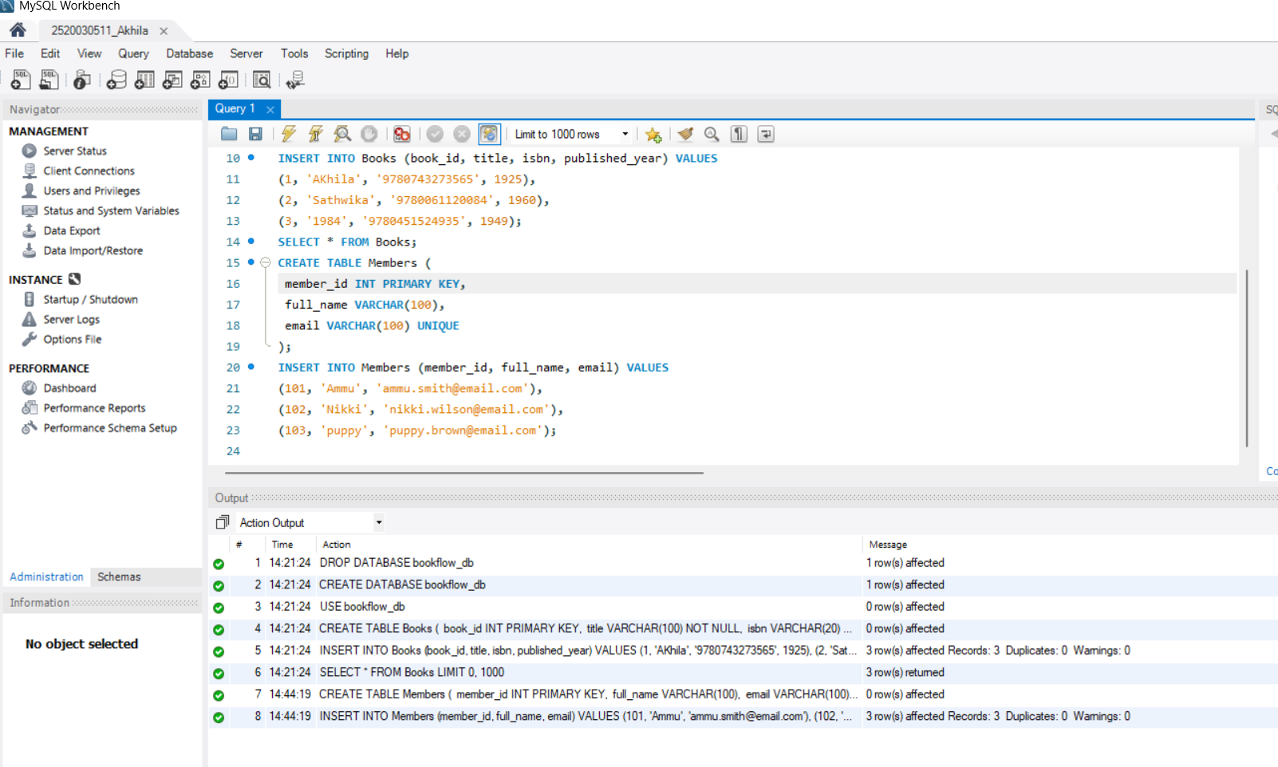
- Insert 10 loans and display

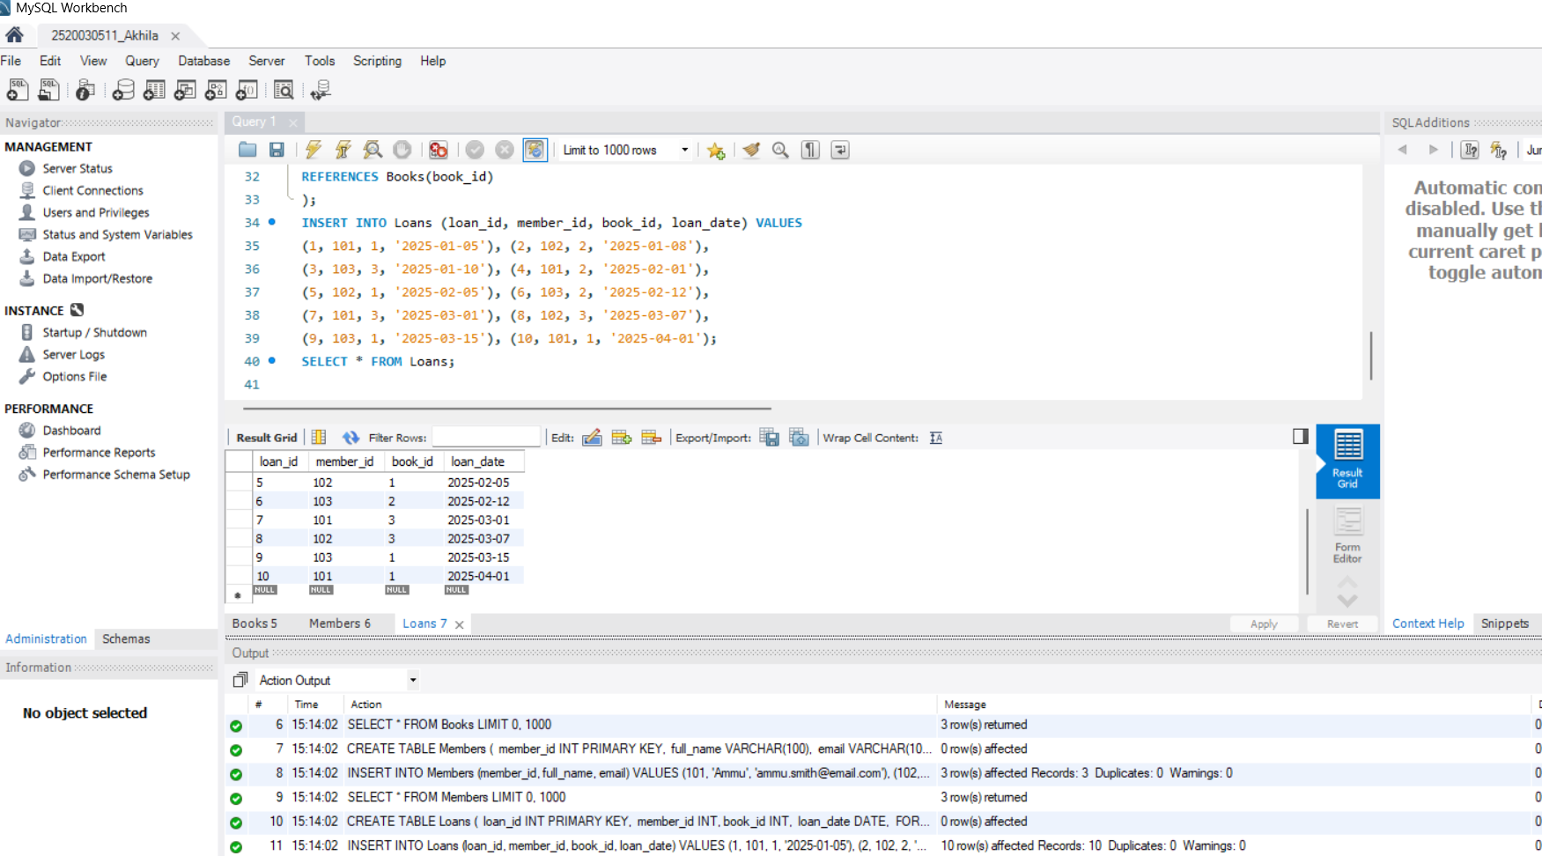

- JOIN Query (Who Borrowed What)

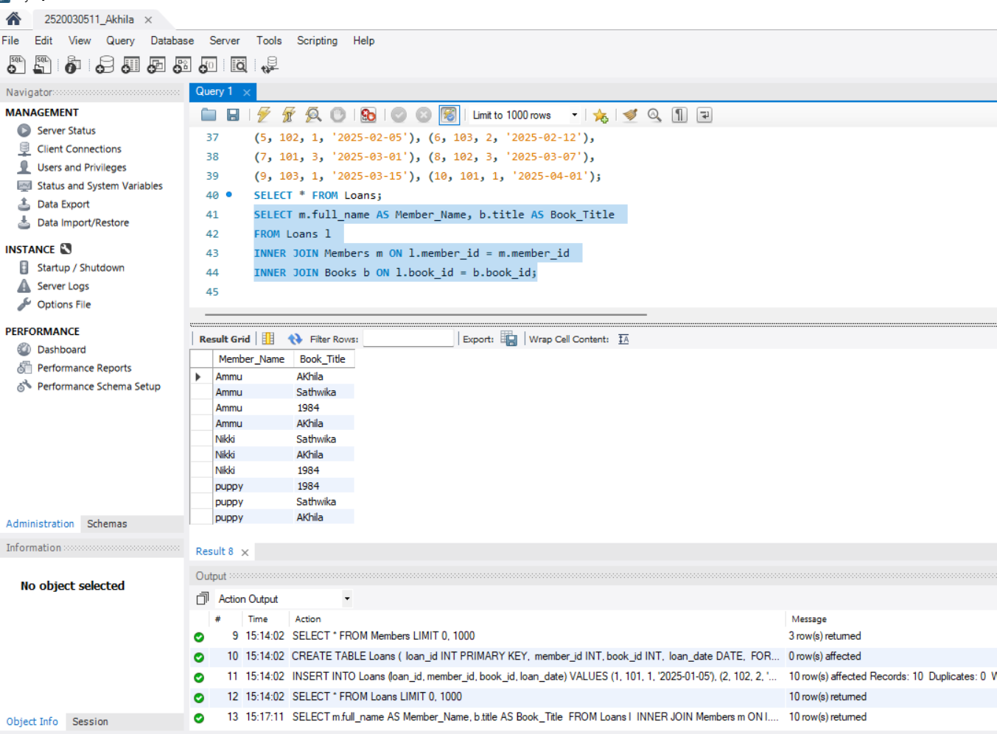
- GROUP BY Query (Books per Year)

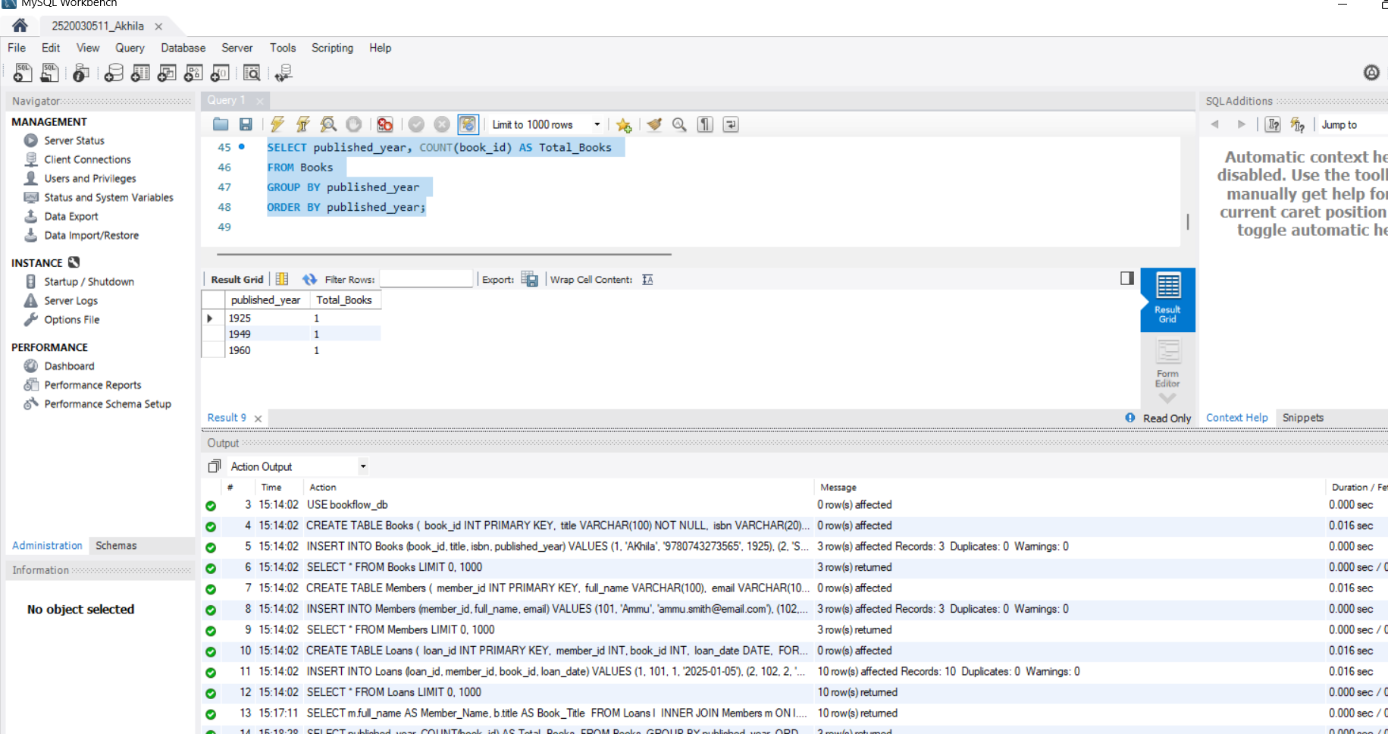

- Donation via TRANSACTION (Atomicity)

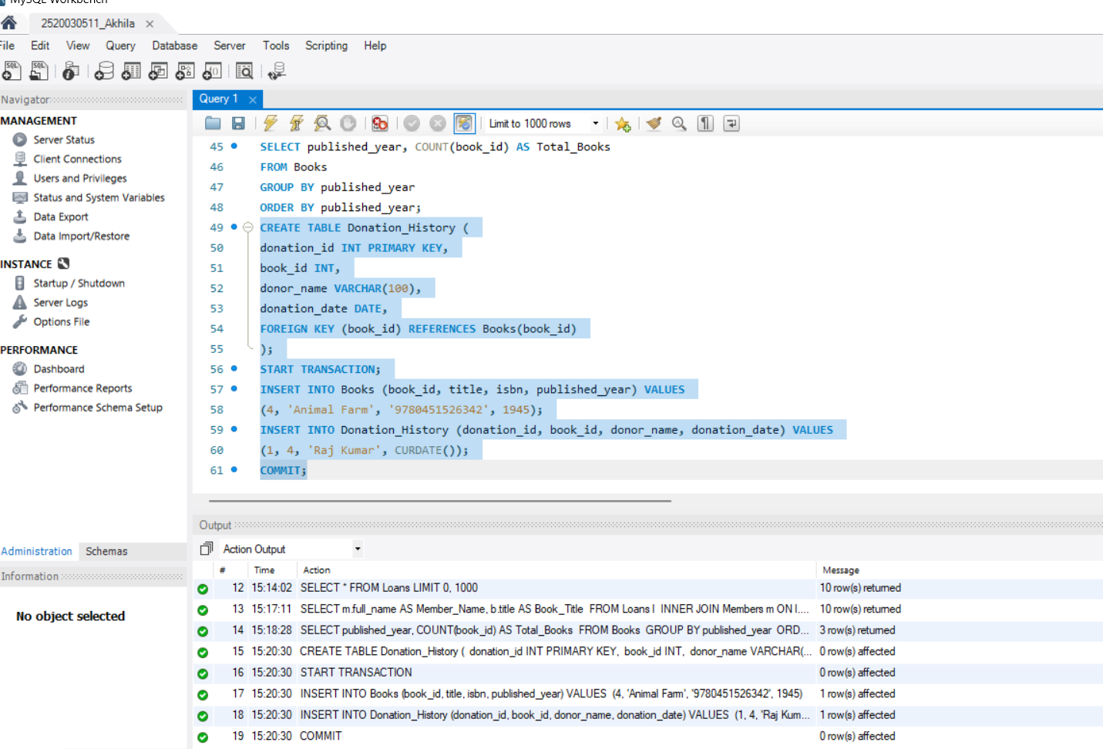

- Index on ISBN + Fast Search

